02 - Lesson 2 – The basics part 2

What has been setup for you
I have set the following up for you:
- A sub domain on aftc.io for you to work on (dan.aftc.io)
This is so you can use a domain space as if you just purchased web hosting
- SSL Security – This enabled HTTPS on the domain name
https://dan.aftc.io
- A new FTP account (email me for details)

So a bit of DNS editing, server configuration and sub account creation on my hosting with Ionos Cloud Servers.

Ok here we...

What you should know now
From lesson 1 you should know the following:
- What ROOT is for a URL / Web Address
- What ROOT is for a location setup for you (e.g. clients.aftc.io/fiverr/dan/dev was your root)
- What ROOT is for file location (e.g. c:\ )
- File naming rules
- Never use spaces, use dashes or minus signs instead
- Never use any special characters
- keep file name all lowercase (There are times when this shouldn’t be done but more on that in a future lesson)
- How to use FTP
- How to understand where you put a file on web server via FTP and where it is as a URL / Web Address in any web browser

I will be assuming from now on you will know the above, if you forget, this is what a Web Dev does, try and test, google and work it out. If your still stuck after that ask me, remember this about you learning and the best way for you to learn is by doing, not by 100% me showing you everything and hoping you get it. It’s not how I learned or any of the best Web Developer’s I’ve met have learned. There’s a lot of work put in for learning, often in your own time in the nights.

Default pages - part 1
Every web server is typically setup to have a default file / starting page, but even if your not using a web server (in your case ePub) and with offline projects there is often a default file / starting page.

Starting pages / default pages are typically:
- index.html (most common for both Linux and windows servers and local development tools)
- index.htm (might not be setup to work but is often used)
- index.php (Linux & windows server that have PHP installed, very common)
- index.aspx (windows servers – for ASP.NET web pages)

So if I was to upload a default page to your new web space and server it would be https://dan.aftc.io/index.html

And it would be uploaded to the public folder, for you on the Ionos server I’ve setup for you it would be httpdocs

Everything starts with a default file, sometimes this can be uniquely setup but most of the time even offline and probably with ePub creation also my guess is that it would index.html also.

Your new hosting environment
Again, email me for the FTP details, they not be shared over fiverr.

Your client are will remain up for you to download lesson files once completed but you will no longer have FTP access to the dev folder in that area of my server any more.

Your new hosting environment is setup to act as if you just bought a domain name and some hosting to go with it.

Your client browsable area is located at:
https://clients.aftc.io/fiverr/dan

Your new lessons domain is:
https://dan.aftc.io/

Your FTP:
Will be supplied once you request it via email.
Web Servers, the root and the public folder
Once you have your FTP details, add it to FileZilla site manager and connect, you will notice that there there is a single folder in there called httpdocs, which is empty.

If you visit your new domain name dan.aftc.io you will see a server error message, 403 access forbidden… But why?

httpdocs is the public folder of your domain dan.aftc.io, only items in there can be seen by the browser. So if you put a file in there called test.txt with the words hello world in there, you would have dan.aftc.io/test.txt available to you.

The root is the folder before the public folder, this is often used as a secure area to store files or sensitive content that should not be accessible via web links. So if I built a web application which allows clients to upload sensitive files, they should never be in the public folder. They should be at the root in a folder and well organised. Then if they are required, the web application should have a login and then a file with some programming in to retrieve that file. Thus keeping it safe from google, web bots and other people downloading it.

The public folder can vary in name from hosting company and server to server, these are the most common names for it:
- httpdocs
- public_html

Default pages part 2

Now that you know the basics of what default pages and their locations are and where the root is on a normal web server, if you visit your web domain I’ve setup for you https://dan.aftc.io you will notice it errors.

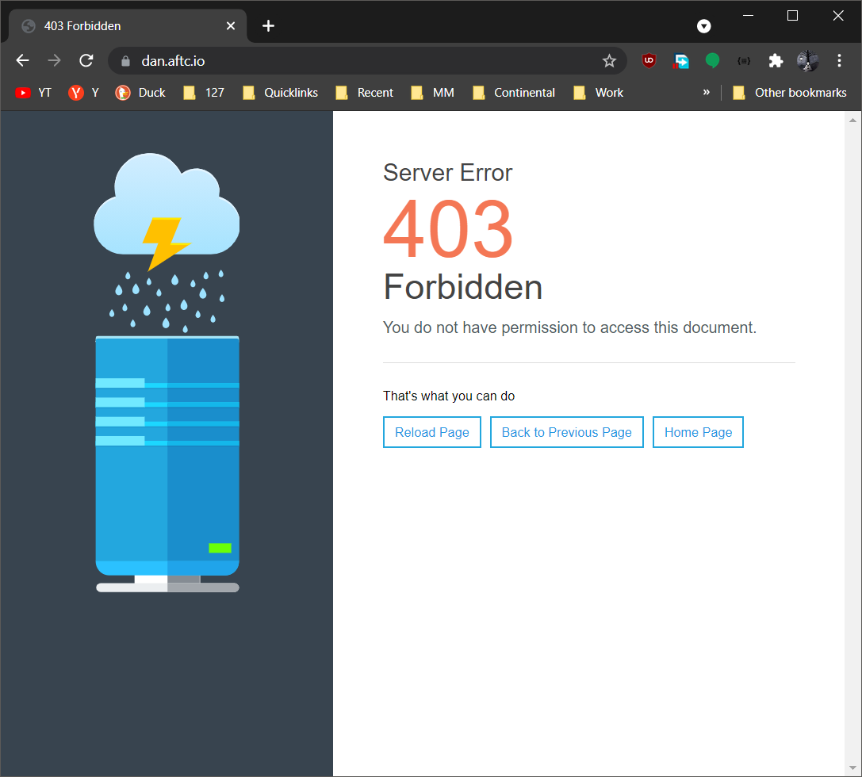

Why? Because there is no default page on your web space in the public folder. This doesn’t always happen as some servers allow directory browsing, which can be turned on and off, but this is a serious security risk and should never be turned on.

I suggest at this point you have a look around your web server via FTP and see what is there.

Lesson 2 – Test 1

Your task is to now upload a default page (file) with the words “Hello World” in to your server in the public folder, if you do this correctly the 403 forbidden page will go away and you will see “Hello World” at https://dan.aftc.io.

Once your done this, send me the link via fiverr or email to check.
Lesson 2 – Test 2

To ensure you have lesson 1 fully understood, I want you to:
- Create a folder in your public folder called test 2
- Create a folder in test 2 called test images
- Upload 10 random images from a google search or anywhere it doesn’t matter
- Then I want you to send me the web links (browser URL’s) to all 10 images via fiverr or email.

HINT: Remember files and folder naming rules, if you see a %20 in the web address, you have done it wrong.
HTML – Basics 1

Here we go, finally getting to some programming…

Here’s the structure of a html page:

<html>
<head></head>
<body></body>
</html>

You should memorise this as it will be in every web page you create, this is not correct as there is more to it than this but you should know this to be the very minimal of what is expected.

HTML Tags
A HTML tag is always wrapped in < > or </ >
<tag name> </tag name>

An opening tag is the one without the / in it so that would be <tag name> is the start of that tag. I like to think of them as containers, it’s easier, especially when it comes to design and animation.

So <b> is a starting tag
and
</b> is an ending tag
The HTML tag <b></b> is short code for bold.

This was updated years ago to be <strong></strong> but many still keep using <b></b> as it’s quicker and easier to type.

Why think of HTML tags as containers?
A HTML element is typically stacking, like this document, you press enter and your on the next line, but when you come to animation and moving things around, those rules are often thrown out the window, and everything becomes a container, which could be anywhere. The trick is working with these rules and combining them.

The HTML Template
You have html, head and body tags.

The HTML tag specified the start and end of HTML.
<HTML> start
</HTML end

The HEAD tag specifies the start and end of the HEAD tag, you will note that tags are inside tags, this is called NESTING and will be in every HTML page you ever build.

So if I write the above HTML example I gave you a different way you will see the nesting a bit better:

<html>
<head></head>
<body></body>
</html>

I have applied indentation, this now clearly shows that the HEAD and BODY tags are inside the HTML tag. E.G.:

The HTML <p> tag is the Paragraph tag, it requires a closing tag, same as the <b> tag, which is the Bold tag.

Here is an example of nesting bold inside a paragraph:

<p>I am not bold, <b>however I am bold</b></p>

HTML – Basics 2

Here’s a more complete structure of a html page:

<html>
<head>
<title>Web Browser Title Here</title>
</head>
<body>
<!-- web page content here -->
</body>
</html>

You should know this off by heart. So what do the other tags do?
The HTML tag
The HTML tag states the start and the end of the HTML code, so what do the rest do and for?

The HEAD tag
The head tag is never something visible, it’s not something you will see on any webpage.
The head tag is used for many things, and can drastically change the way your webpage works, it can be used for:

- Setting the Web Browser title or maybe ePub page title of the page your viewing
- Linking to a CSS file
- Embedding (which means writing) CSS code directly into the HTML page
- Linking to a JavaScript file
- Embedding JavaScript code directly into the HTML page
- Setting up how mobiles zoom and can zoom on your content
- Meta tagging for SEO and search engines to use

and more...
The BODY tag
The BODY tag states the start and the end of what will be displayed on your web page, nothing should be outside of these tags, if it is your doing it wrong. The only other place you will work on is the HEAD tag. Which is why you need to memories the above structure.
Embedded tags
As you can see from the example, html is the outer container or wrapper, the HEAD and BODY tags are both inside the HTML tag.

Lesson 2 – Test 3

Now I want you to create a HTML file called lesson 2 test 3, it must have the basics of what I detailed above and have the following words display in the web page, “Hello I am Lesson 2 – Test 3”. I want you to upload this to the server, locate that file in your web browser and send me the link.

HINT: Remember files and folder naming rules, if you see a %20 in the web address, you have done it wrong.
Common HTML tags

<b></b>
This is the bold tag

<strong></strong>
This is the bold tag, but the modern version of it.

<br>
This is the line break tag, NOTE: this doesn’t have a closing tag, some do not, but only very few.
<p></p>
This is the paragraph tag. Big gaps. Use the <BR> tag when you want a single line break inside P tags.

<hr>
Horizontal line tag. Again NOTE it doesn’t have a closing tag.

<div></div>
This is a container, or a division, I pref’ to think of them as containers. A p tag can be a container, a B or HR tag should not be thought of as containers.
<span></span>
This is another container tag, but has different built in styling properties to a DIV or P tag. If you use the span tag in a div tag, the content wont go to the next line.
Lesson 2 – Test 4

Now I want you to create a HTML file called lesson 2 test 4, it must have the basics of what I detailed above and have a paragraph tag used, with some wording in it that is bold and some that is not. I want a sentence which could be anything you want to start off unbold (not bold) and then mid sentence change to bold, then some words which are bold, then I want the bolding to stop and some more words which are not bold after it. E.G.
Hello I am from South Wales, it rains a lot here…
Once done, upload and send me the web link.
Lesson 2 – Things to remember

- You should have a folder on your computer called training
- In that folder you should have 3 folders:
- Backups (so you can backup things at a certain time if you want to, I do this and store things in zip or 7z files named dates e.g. 2021-09-01.zip)
- Server
This is the folder that should be the mirror of your servers contents (what’s on FTP)
- Scratchings or Notes
This folder would be for files you wish to keep that you have made tests on, and would like to reference to again. Or notes you have made, or tests you have done. These files should not be put on the server. You can put them on the server to test, but for lesson completion they should not be on the server. In some projects I have 50+ of these files. I even have a private github repository of notes on every language I know and quick handy notes and code snippets (I can’t remember everything, all the time).
- Keep testing, trying out things, if you don’t know something, google it first, we got to level your google kung fu skills up. You got to be able to search and learn, this will become even more important when we get to CSS and JavaScript. But if your stuck, email me and I will help as always.

